VistA System Monitor (VSM) 2.0

User Manual



April 2018

Department of Veterans Affairs (VA)

Office of Information and Technology (OIT)

Enterprise Program Management Office (EPMO)

Capacity and Performance Engineering (CPE)

Revision History

| Date | Revision | Description | Author |
| --- | --- | --- | --- |
| 04/16/2018 | 1.0 | Initial VistA System Monitor (VSM) 2.0 User Manual. Includes the latest monitors:   * VistA Timed Collection Monitor (VTCM) * VistA Storage Monitor (VSTM) * VistA Business Event Monitor (VBEM) * VistA Message Count Monitor (VMCM) * VistA HL7 Monitor (VHLM) | EPMO CPE |

Table of Contents

Revision History ii

List of Figures iii

List of Tables iv

Orientation v

1 Introduction 1

1.1 Purpose 1

1.2 Data Collection 1

1.2.1 VistA Timed Collection Monitor (VTCM) 2

1.2.2 VistA Storage Monitor (VSTM) 2

1.2.3 VistA Business Event Monitor (VBEM) 2

1.2.4 VistA Message Count Monitor (VMCM) 3

1.2.5 VistA HL7 Monitor (VHLM) 3

1.3 Data Storage and Analysis 4

1.4 Package Management 4

2 VSM Operation 5

2.1 VSM MANAGEMENT Option 5

2.2 Status and Operational Actions 6

2.2.1 Start Monitor Action 6

2.2.2 Stop Monitor Action 7

2.2.3 View CFG Action 8

2.2.4 Edit CFG Action 9

2.2.5 REST—Restore CFG Action 10

2.2.6 DEL—Delete Data Action 10

3 Appendix A—VistA System Monitor (VSM) Metrics 11

3.1 VistA Timed Collection Monitor (VTCM) 11

3.2 VistA Storage Monitor (VSTM) 11

3.3 VistA Business Event Monitor (VBEM) 11

3.4 VistA Message Count Monitor (VMCM) 12

3.5 VistA HL7 Monitor (VHLM) 12

List of Figures

Figure 1: VSM Management Menu 5

Figure 2: VSM Management Display 5

Figure 3: Start Monitor 6

Figure 4: Stop Monitor 7

Figure 5: View Configuration 8

Figure 6: Edit Configuration 10

List of Tables

Table 1: Documentation Symbol Descriptions vi

Table 2: VSM MANAGEMENT Display Description 5

Table 3: View Configuration Field Definitions 8

Table 4: VistA Timed Collection Monitor (VTCM) Metrics 11

Table 5: VistA Storage Monitor (VSTM) Metrics 11

Table 6: VistA Business Event Monitor (VBEM) Metrics 11

Table 7: VistA Message Count Monitor (VMCM) Metrics 12

Table 8: VistA HL7 Monitor (VHLM) Metrics 12

Orientation

How to Use this Manual

The purpose of this guide is to provide instructions for use and maintenance of the Veterans Health Information Systems and Technology Architecture (VistA) Capacity and Performance Engineering (CPE) VistA System Monitor (VSM) 2.0 software.

Throughout this manual, advice and instructions are offered regarding the use of the VSM software and the functionality it provides for Veterans Health Information Systems and Technology Architecture (VistA) software products.

Intended Audience

The intended audience of this manual is the following stakeholders:

* **Enterprise Program Management Mode (EPMO)—**System engineers and Capacity Management personnel responsible for enterprise capacity planning and system architecture.
* **System Administrators—**System administrators and Capacity Management personnel at local and regional Department of Veterans Affairs (VA) sites who are responsible for computer management and system security on the VistA M Servers.
* **EPMO Developers—**VistA legacy development teams.
* **Product Support (PS)**.

Disclaimers

Software Disclaimer

This software was developed at the Department of Veterans Affairs (VA) by employees of the Federal Government in the course of their official duties. Pursuant to title 17 Section 105 of the United States Code this software is *not* subject to copyright protection and is in the public domain. VA assumes no responsibility whatsoever for its use by other parties, and makes no guarantees, expressed or implied, about its quality, reliability, or any other characteristic. We would appreciate acknowledgement if the software is used. This software can be redistributed and/or modified freely provided that any derivative works bear some notice that they are derived from it, and any modified versions bear some notice that they have been modified.

Documentation Disclaimer

This manual provides an overall explanation of using the VistA System Monitor (VSM) 2.0 software; however, no attempt is made to explain how the overall VistA programming system is integrated and maintained. Such methods and procedures are documented elsewhere. We suggest you look at the various VA internet and intranet SharePoint sites and websites for a general orientation to VistA. For example, visit the Office of Information and Technology (OIT) Enterprise Program Management Office (EPMO) intranet website.

 DISCLAIMER: The appearance of any external hyperlink references in this manual does *not* constitute endorsement by the Department of Veterans Affairs (VA) of this website or the information, products, or services contained therein. The VA does *not* exercise any editorial control over the information you find at these locations. Such links are provided and are consistent with the stated purpose of this VA intranet service.

Documentation Conventions

This manual uses several methods to highlight different aspects of the material:

* Various symbols are used throughout the documentation to alert the reader to special information. Table 1 gives a description of each of these symbols:

Table : Documentation Symbol Descriptions

| Symbol | Description |
| --- | --- |
| Note | **NOTE / REF:** Used to inform the reader of general information including references to additional reading material. |
| Caution | **CAUTION / RECOMMENDATION / DISCLAIMER:** Used to caution the reader to take special notice of critical information. |

* Descriptive text is presented in a proportional font (as represented by this font).
* Conventions for displaying TEST data in this document are as follows:
* The first three digits (prefix) of any Social Security Numbers (SSN) begin with either “**000**” or “**666**”.
* Patient and user names are formatted as follows:
* *<APPLICATION NAME/ABBREVIATION/NAMESPACE>*PATIENT,*<N>*
* *<APPLICATION NAME/ABBREVIATION/NAMESPACE>*USER,*<N>*

Where “<*APPLICATION NAME/ABBREVIATION/NAMESPACE>*” is defined in the Approved Application Abbreviations document and “<*N*>” represents the first name as a number spelled out or as a number value and incremented with each new entry.

For example, in VSM (KMPV) test patient and user names would be documented as follows:

* KMPVPATIENT,ONE or KMPVUSER,ONE
* KMPVPATIENT,TWO or KMPVUSER,TWO
* KMPVPATIENT,THREE or KMPVUSER,THREE
* KMPVPATIENT,14 or KMPVUSER,14
* Etc.
* “Snapshots” of computer online displays (i.e., screen captures/dialogues) and computer source code is shown in a *non*-proportional font and may be enclosed within a box.
* User’s responses to online prompts are **bold** typeface and highlighted in yellow (e.g., **<Enter>**). The following example is a screen capture of computer dialogue, and indicates that the user should enter two question marks:

Select Primary Menu option: **??**

* Emphasis within a dialogue box is **bold** typeface and highlighted in blue (e.g., STANDARD LISTENER: RUNNING).
* Some software code reserved/key words are **bold** typeface with alternate color font.
* References to “**<Enter>**” within these snapshots indicate that the user should press the **Enter** key on the keyboard. Other special keys are represented within **< >** angle brackets. For example, pressing the **PF1** key can be represented as pressing **<PF1>**.
* Author’s comments are displayed in italics or as “callout” boxes.

 **NOTE:** Callout boxes refer to labels or descriptions usually enclosed within a box, which point to specific areas of a displayed image.

* This manual refers to the M programming language. Under the 1995 American National Standards Institute (ANSI) standard, M is the primary name of the MUMPS programming language, and MUMPS is considered an alternate name. This manual uses the name M.
* All uppercase is reserved for the representation of M code, variable names, or the formal name of options, field/file names, and security keys (e.g., the XUPROGMODE security key).

 **NOTE:** Other software code (e.g., Delphi/Pascal and Java) variable names and file/folder names can be written in lower or mixed case (e.g., CamelCase).

Documentation Navigation

This document uses Microsoft® Word’s built-in navigation for internal hyperlinks. To add **Back** and **Forward** navigation buttons to the toolbar, do the following:

1. Right-click anywhere on the customizable Toolbar in Word (*not* the Ribbon section).
2. Select **Customize Quick Access Toolbar** from the secondary menu.
3. Select the drop-down arrow in the “**Choose commands from:**” box.
4. Select **All Commands** from the displayed list.
5. Scroll through the command list in the left column until you see the **Back** command (green circle with arrow pointing left).
6. Select/Highlight the **Back** command and select **Add** to add it to your customized toolbar.
7. Scroll through the command list in the left column until you see the **Forward** command (green circle with arrow pointing right).
8. Select/Highlight the **Forward** command and select **Add** to add it to the customized toolbar.
9. Select **OK**.

You can now use these **Back** and **Forward** command buttons in the Toolbar to navigate back and forth in the Word document when selecting hyperlinks within the document.

 **NOTE:** This is a one-time setup and is automatically available in any other Word document once you install it on the Toolbar.

How to Obtain Technical Information Online

Exported VistA M Server-based software file, routine, and global documentation can be generated using Kernel, MailMan, and VA FileMan utilities.

 **NOTE:** Methods of obtaining specific technical information online is indicated where applicable under the appropriate section.

Help at Prompts

VistA M Server-based software provides online help and commonly used system default prompts. Users are encouraged to enter question marks at any response prompt. At the end of the help display, you are immediately returned to the point from which you started. This is an easy way to learn about any aspect of VistA M Server-based software.

Obtaining Data Dictionary Listings

Technical information about VistA M Server-based files and the fields in files is stored in data dictionaries (DD). You can use the **List File Attributes** [DILIST] option on the **Data Dictionary Utilities** [DI DDU] menu in VA FileMan to print formatted data dictionaries.

 **REF:** For details about obtaining data dictionaries and about the formats available, see the “List File Attributes” section in the “File Management” section in the *VA FileMan Advanced User Manual*.

Assumptions

This manual is written with the assumption that the reader is familiar with the following:

* VistA computing environment:
* Kernel—VistA M Server software
* VA FileMan data structures and terminology—VistA M Server software
* Microsoft® Windows environment
* M programming language

Reference Materials

Readers who wish to learn more about VSM should consult the following:

* *VistA System Monitor (VSM) Installation, Back-Out, and Rollback Guide*
* *VistA System Monitor (VSM) User Manual* (this manual)
* *VistA System Monitor (VSM) Technical Manual*
* Capacity and Performance Engineering (CPE) website (for more information on CPE services).

This site contains other information and provides links to additional documentation.

VistA documentation is made available online in Microsoft® Word format and in Adobe® Acrobat Portable Document Format (PDF). The PDF documents *must* be read using the Adobe® Acrobat Reader, which is freely distributed by Adobe® Systems Incorporated at: <http://www.adobe.com/>

VistA documentation can be downloaded from the VA Software Document Library (VDL): <http://www.va.gov/vdl/>

 **REF:** See the [VistA System Monitor (VSM) manuals on the VDL](http://www.va.gov/vdl/application.asp?appid=218).

VistA documentation and software can also be downloaded from the Product Support (PS) Anonymous Directories.

# Introduction

## Purpose

The VistA System Monitor (VSM) 2.0 software is intended to collect Caché and VistA metrics related to system capacity and business usage. The package is made up of multiple collectors. Five collectors deployed are the following:

* **VistA Timed Collection Monitor (VTCM)—**Collects Caché metrics at regularly scheduled intervals such that they can be used in conjunction with metrics gathered via other deployed collection tools.
* **VistA Storage Monitor (VSTM)—**Collects storage metrics for each database once daily.
* **VistA Business Event Monitor (VBEM)—**Collects Caché metrics for VistA functions (Menu Options, TaskMan Jobs and Remote Procedure Calls).
* **VistA Message Count Monitor (VMCM)—**Collects inbound and outbound Health Level Seven (HL7) and HL7 Optimized (HLO) message counts at regularly scheduled intervals.
* **VistA HL7 Monitor (VHLM)—**Collects metadata about HL7 messages (**SYNC** and **ASYNC**) as well as HLO messages.

This data is used for understanding VistA systems as they relate to the infrastructure on which they are deployed.

VSM provides automated VistA monitoring services developed by Capacity & Performance Engineering (CPE). This entails the daily capture of VistA related Caché metrics. These metrics are automatically transferred to the CPE national database for storage and analysis.

This software is designed to be fully automated, *not* needing support from the local or regional system administrators. However, support features are available for both local support staff and remote CPE engineers for situations that may call for hands on support.

The current version of this software is intended for VistA sites running on InterSystem’s Caché.

## Data Collection

VSM monitors are designed to collect data over the course of each day:

1. Data is transferred to the CPE national database on a nightly basis.
2. Upon receipt of this data the national server sends an acknowledgement to the site.
3. Once the site receives this acknowledgement it immediately deletes that data from its system.

As a failsafe:

* A purge function is executed every time a monitor is started and every time a TaskMan task is run to transfer data. This purge function deletes any data that is older than the number of days specified in the DAYS TO KEEP DATA (#1.01) field in the VSM CONFIGURATION (#8969) file for that monitor type.
* Additionally, a MailMan “**warning**” message is sent to the CPE support email address if the TaskMan task to transfer data finds data older than **1** day.
* Lastly, there is a “**kill switch**” available to the sites in case of emergency. This is detailed in Section 2.2.6, “DEL—Delete Data Action.”

### VistA Timed Collection Monitor (VTCM)

The **VistA Timed Collection Monitor (VTCM)** is intended to collect Caché metrics on a regularly scheduled interval. By default this interval is every **15** minutes and should *not* be changed without consultation with CPE support. Data collected will include the following metrics:

* Global references
* Routine lines executed
* Physical block **READ**s/**WRITE**s

The data is stored in the **^KMPTMP (“KMPV”,”VTCM”** global. This data is transferred to the CPE national server via MailMan on a **nightly** basis and purged from the local site.

There is a purge function that is executed every time any VSM monitor is run, which verifies that data is being purged from this temporary global and *not* using unnecessary storage space.

 **REF:** For functional and operational details, see Section 2, “VSM Operation.”  
  
A list of metrics collected by this monitor can be found in “Appendix A—VistA System Monitor (VSM) Metrics.”

### VistA Storage Monitor (VSTM)

The **VistA Storage Monitor (VSTM)** is intended to collect storage metrics once daily. Data collected includes:

* Max Size
* Size
* Available
* %Free
* Disk Free

The data is stored in the **^KMPTMP (“KMPV”,”VSTM”** global. This data is transferred to the CPE national server via MailMan **twice** a month and purged from the local site.

There is a purge function that is executed every time any VSM monitor is run, which verifies that data is being purged from this temporary global and *not* using unnecessary storage space.

 **REF:** For functional and operational details, see Section 2, “VSM Operation.”  
  
A list of metrics collected by this monitor can be found in “Appendix A—VistA System Monitor (VSM) Metrics.”

### VistA Business Event Monitor (VBEM)

The **VistA Business Event Monitor (VBEM)** is intended to collect Cache metrics for VistA Functions (Menu Options, TaskMan Jobs and Remote Procedure Calls). This functionality will replace current Resource Utilization Monitor (RUM) functionality for VistA functions. Data collected includes:

* CPU Time
* Routine Lines
* Global References
* Occurrences

The data is stored in the **^KMPTMP (“KMPV”,”VBEM”** global. This data is transferred to the CPE national server via MailMan on a **nightly** basis and purged from the local site.

There is a purge function that is executed every time any VSM monitor is run, which verifies that data is being purged from this temporary global and *not* using unnecessary storage space.

 **REF:** For functional and operational details, see Section 2, “VSM Operation.”  
  
A list of metrics collected by this monitor can be found in “Appendix A—VistA System Monitor (VSM) Metrics.”

### VistA Message Count Monitor (VMCM)

The **VistA Message Count Monitor (VMCM)** is intended to collect HL7 and HLO message counts on a regularly scheduled interval. By default this interval is every **15** minutes and should *not* be changed without consultation with CPE support. Data collected include inbound and outbound message counts from logical links as well as HLO queues.

The data is stored in the **^KMPTMP (“KMPV”,”VMCM”** global. This data is transferred to the CPE national server via MailMan on a **nightly** basis and purged from the local site.

There is a purge function that is executed every time any VSM monitor is run, which verifies that data is being purged from this temporary global and *not* using unnecessary storage space.

 **REF:** For functional and operational details, see Section 2, “VSM Operation.”  
  
A list of metrics collected by this monitor can be found in “Appendix A—VistA System Monitor (VSM) Metrics.”

### VistA HL7 Monitor (VHLM)

The **VistA HL7 Monitor (VHLM)** is intended to collect metadata about both HL7 and HLO messages. By default this interval is every **720** minutes (**twice** a day) and should *not* be changed without consultation with CPE support. Data collected includes:

* Logical Link
* Sending/Receiving Application
* Sending/Receiving Locations
* Subscriber Protocol

The data is stored in the **^KMPTMP (“KMPV”,”VHLM”** global. This data is transferred to the CPE national server via MailMan on a **nightly** basis and purged from the local site.

There is a purge function that is executed every time any VSM monitor is run, which verifies that data is being purged from this temporary global and *not* using unnecessary storage space.

 **REF:** For functional and operational details, see Section 2, “VSM Operation.”  
  
A list of metrics collected by this monitor can be found in “Appendix A—VistA System Monitor (VSM) Metrics.”

## Data Storage and Analysis

Data transferred to the CPE national server is stored in Caché Object/SQL tables. This data is then used to populate InterSystem’s DeepSee cubes, providing the ability for CPE analysts to access, organize, export, and report on the data as needed.

The data collected at the VistA sites is collected in a fashion that allows CPE to directly correlate VSM data with that collected from other monitoring and collection tools currently in use. This data is used for purposes, such as capacity planning and system/infrastructure engineering.

## Package Management

This software is intended to run automatically in the background and should require no operational support under normal operations. However, for those times where support is needed there are two mechanisms within this package to provide such functionality:

* **Local Operational Support:** There is a List Manager Application installed with this package that allows the local support staff to:
* Start and stop monitors
* View operational parameters
* Configure operational parameters
* Delete all locally stored data in case of emergency

 **REF:** These actions are documented in Section 2, “VSM Operation.”

* **National CPE Support:** Additionally, this software has the capability to receive requests for the same functions via MailMan messages from the CPE VSM Support group.

# VSM Operation

## VSM MANAGEMENT Option

The **VSM MANAGEMENT** [KMPV VSM MANAGEMENT] option is located under the **Capacity Planning** [XTCM MAIN] menu as depicted in Figure 1:

Figure 1: VSM Management Menu

Select Systems Manager Menu Option: **Capacity Planning**

RUM RUM Manager Menu ...

CPG Capacity Planning Mail Group Edit

TLS CP Tools Manager Menu ...

VSM VSM MANAGEMENT

Select Capacity Planning Option: **VSM MANAGEMENT**

The **VSM MANAGEMENT** [KMPV VSM MANAGEMENT] option displays the VSM MANAGEMENT List Manager application, as shown in Figure 2:

Figure : VSM Management Display

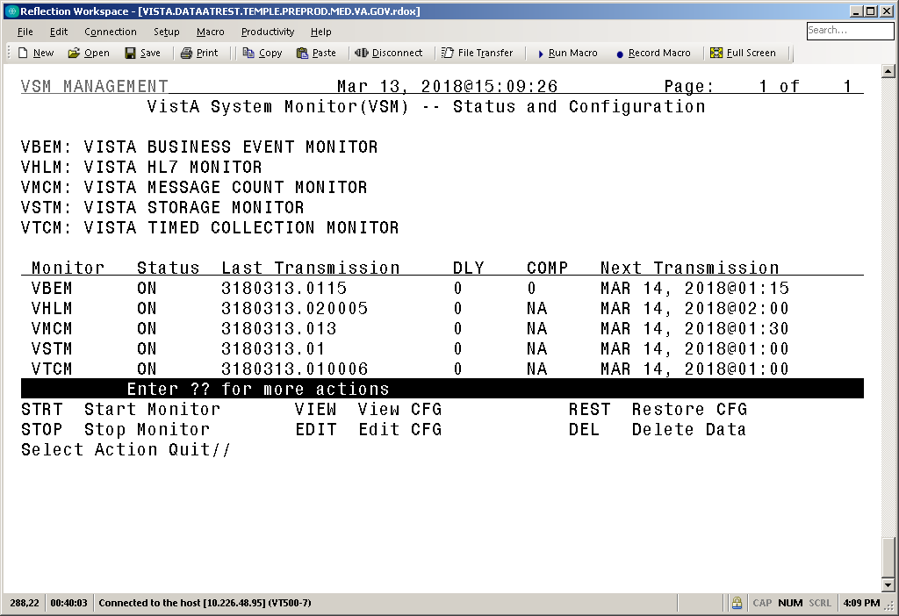

This option provides status and operational actions for each monitor installed (see Section 2.2, “Status and Operational Actions”). Installed monitors are listed with their Monitor Key and Full Name for clear identification.

Table 2 lists the information displayed for each monitor:

Table 2: VSM MANAGEMENT Display Description

| Field Caption | Description |
| --- | --- |
| Monitor | The **four**-character Monitor Key associated with the specific monitor. |
| Status | **ON** or **OFF** status of monitor. |
| Last Transmission | Date/Time data was last transmitted to the VSM national database. |
| DLY | The number of nodes (**one** node per day) currently in the “**DLY**” node of the **^KMPTMP(“KMPV”,MonitorKey** temporary global. Under normal circumstances, this value is always **1**. If this number is more than **1** the field blinks to alert the user of a potential problem. Data beyond **7** days is automatically purged. |
| COMP | If applicable, the number of nodes (**one** node per day) currently in the “**COMPRESS**” node of the **^KMPTMP(“KMPV”,MonitorKey** temporary global. Under normal circumstances this value is always **1**. If this number is more than **1** the field blinks to alert the user of a potential problem. Data beyond **7** days is automatically purged. |
| Next Transmission | Date/Time scheduled for next transmission of data to the VSM national database. |

 **REF:** Screen shots and descriptions of each action in the “VSM MANAGEMENT” screen are listed in Section 2.2, “Status and Operational Actions.”

## Status and Operational Actions

### Start Monitor Action

The **STRT** (Start Monitor) action executes two tasks:

1. Sets the ONOFF (#.02) field in the VSM CONFIGURATION (#8969) file to **1 (ON)** for the given monitor.
2. Schedules the daily TaskMan task, which transfers the data from the local site to the Capacity and Performance Engineering (CPE) national database.

Upon starting a monitor, a message is sent to the CPE national server to automatically update its configuration file with the new monitor state.

Figure 3: Start Monitor

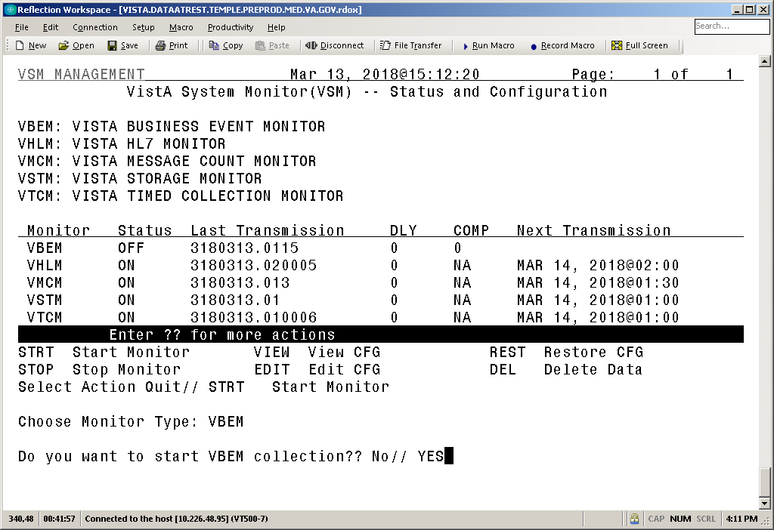

### Stop Monitor Action

The **STOP** (Stop Monitor) action executes two tasks:

1. Sets the ONOFF (#.02) field in the VSM CONFIGURATION (#8969) file to **0** (**OFF**) for the given monitor.
2. Un-schedules the daily TaskMan task, which transfers the data from the local site to the CPE national database.

The specified monitor stops collecting metrics upon its next iteration as it checks the value of the ONOFF (#.02) field in the VSM CONFIGURATION (#8969) file prior to each execution. Data already collected for that day is either transferred once the monitor is restarted or purged once past the purge period. Upon stopping a monitor, a message is sent to the CPE national server to automatically update its configuration file with the new monitor state.

 **NOTE:** The **VistA Timed Collection Monitor (VTCM)** and the **VistA Message Count Monitor (VMCM)** collect data via routines running on each individual node as started by the Caché Task Manager. Once stopped and then restarted, collections do *not* resume until the next day when the Caché Task Manager starts the monitors on each node.

Figure 4: Stop Monitor

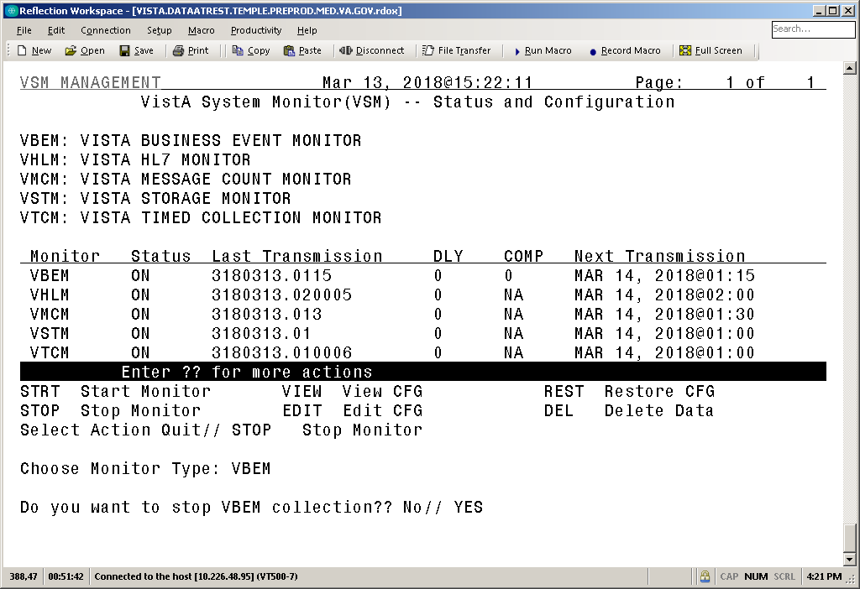

### View CFG Action

The **VIEW** (View CFG [configuration]) action opens a read-only ScreenMan display. This provides an at-a-glance view of how the selected monitor is configured (Figure 5). Displayed fields are from the VSM CONFIGURATION (#8969) file. A definition of these fields is listed in Table 3.

Figure 5: View Configuration

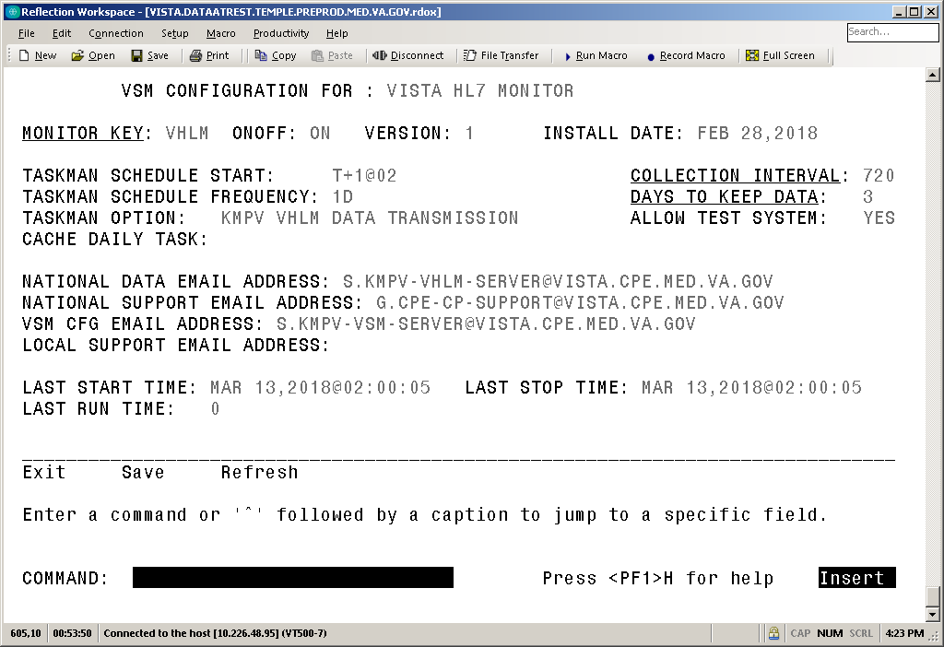

Table 3 lists and defines the fields in the VSM CONFIGURATION (#8969) file:

Table 3: View Configuration Field Definitions

| Field Name | Field Number | Description |
| --- | --- | --- |
| MONITOR KEY | 8969, .01 | **Two** to **four** Letter acronym used to identify specific monitor. |
| ONOFF | 8969, .02 | Flag used to stop or continue monitor collection. |
| VERSION | 8969, .04 | Current version of VSM software. |
| INSTALL DATE | 8969, .05 | Date current version of software was installed. |
| DAYS TO KEEP DATA | 8969, 1.01 | Number of days that unsent data is allowed to remain in **^KMPTMP("KMPV"** before the purge routine kills it. Limited to **3-7** days. Data older than this value is deleted; regardless of reason it has *not* been sent to the national database, in order to assure global does *not* grow unchecked. |
| COLLECTION INTERVAL | 8969, 1.02 | The number in minutes used to gather or aggregate metrics. Monitors that collect metrics on a periodic basis use this value to wait between collections. Monitors that collect data continuously use this value for aggregation of metrics. |
| CACHE DAILY TASK | 8969, 1.03 | The name of the routine, if applicable, to start each days collection. The Caché Task Manager calls the **RUN** line tag of this routine at the start of every day. This allows collection tasks to run on each node of a VistA system: **front-end** and **back-end**. |
| ALLOW TEST SYSTEM | 8969, 1.04 | If set to **YES** this allows the monitors to run on test systems. Otherwise, monitors exit if the current UCI is *not* set as **PROD** per **^%ZOSF(“UCI”)**. |
| TASKMAN SCHEDULE FREQUENCY | 8969, 1.05 | The value used to automatically reschedule the TaskMan tasks. (e.g., **1D** or **1W**) |
| TASKMAN SCHEDULE START | 8969, 1.06 | The time each monitor's TaskMan task should be scheduled. (e.g., **T+1@0001**) |
| TASKMAN OPTION | 8969, 1.07 | The OPTION (#19) file entry used by TaskMan to schedule the daily background jobs. |
| LAST START TIME | 8969, 2.01 | Time last TaskMan task was started for a specific monitor. |
| LAST STOP TIME | 8969, 2.02 | Time last TaskMan task completed for a specific monitor. |
| LAST RUN TIME | 8969, 2.03 | Time in seconds from start to completion of most recent run for a specific monitor TaskMan task. |
| NATIONAL DATA EMAIL ADDRESS | 8969, 3.01 | Email address used to send metric data to the national CPE database. |
| NATIONAL SUPPORT EMAIL ADDRESS | 8969, 3.02 | Email address used to send messages to the CPE VistA CP mail group. |
| VSM CFG EMAIL ADDRESS | 8969, 3.03 | Email address used to send data other than daily metrics to CPE national database. |
| LOCAL SUPPORT EMAIL ADDRESS | 8969, 3.04 | Optional email address for local support personnel. If present any email that would be sent to the national support group also goes to the local support group. |

### Edit CFG Action

The **EDIT** (Edit CFG [configuration]) action opens an editable ScreenMan display. This allows the user to edit certain configuration parameters for a specific monitor. Definitions for editable fields are listed in Table 3.

* Changes *must* be saved upon exiting the ScreenMan display in order to take effect.
* Changes take effect immediately.

Upon editing a monitor configuration parameter, a message is sent to the CPE national server to automatically update its configuration file with the new monitor state.

 **NOTE:** Using **EDIT CFG** you can enter the name of a local mail group if desiring to receive emails when configuration has been changed.

 CAUTION: This action should only be taken with consultation from CPE support staff as it could impact the quality of metrics collected.

Figure 6: Edit Configuration

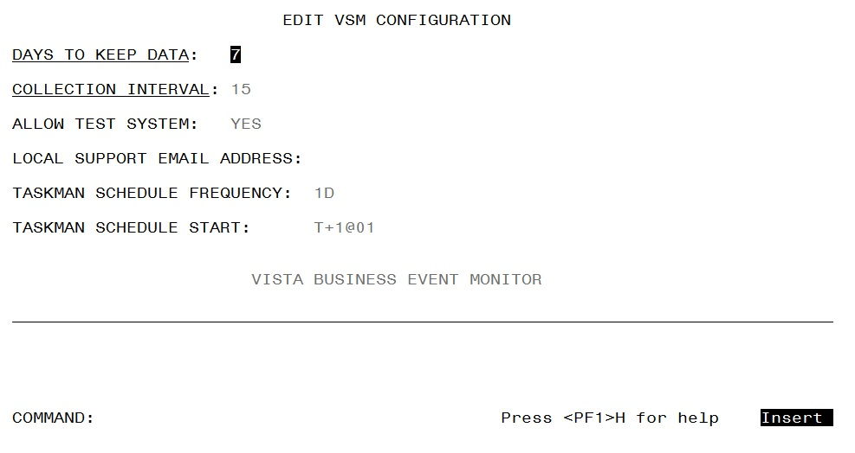

### REST—Restore CFG Action

The **REST** (Restore CFG [configuration]) action restores default monitor parameters as stored in the VSM MONITOR DEFAULTS (#8969.02) file for a specific monitor.

Upon restoration of monitor configuration values, a message is sent to the CPE national server to automatically update its configuration file with the new monitor state.

### DEL—Delete Data Action

The **DEL** (Delete Data) action is for emergency use only. This action deletes *all* data for the specified monitor and sets the ONOFF (#.02) field in the VSM CONFIGURATION (#8969) file to **OFF** (**0**). This action is effectively an emergency “**kill switch**”.

Upon deletion of data, a message is sent to the CPE national server to automatically update its configuration file and alert CPE support that there is an emergency.

 CAUTION: This action can be taken *without* consultation with CPE support staff. However, it should only be taken in the case of an emergency, such as an unchecked growth in global size due to unforeseen circumstances. This option is effectively a monitor “kill switch.”

# Appendix A—VistA System Monitor (VSM) Metrics

## VistA Timed Collection Monitor (VTCM)

Table 4 lists the metrics collected by the **VistA Timed Collection Monitor (VTCM)**:

Table 4: VistA Timed Collection Monitor (VTCM) Metrics

| Metric | Metric |
| --- | --- |
| Global References | SMH Memory Used Percentage where applicable |
| Global References per Second | SMH Page Used where applicable |
| Global Sets and Kills | SMH Page Used Percentage where applicable |
| Logical Block Requests | CSP Sessions |
| Physical Block Reads | Caché Efficiency |
| Physical Block Writes | ECP Client Bytes per Second |
| Processes | ECP Server Bytes per Second |
| Routine Commands | Paging where available |
| Routine Lines | Page Space where applicable |
| Routine References | Physical Memory where applicable |
| SMH Memory Used where applicable |  |

## VistA Storage Monitor (VSTM)

Table 5 lists the metrics collected by the **VistA Storage Monitor (VSTM)**:

Table 5: VistA Storage Monitor (VSTM) Metrics

| Metric | Description |
| --- | --- |
| Max Size | Maximum size allowed for database growth. |
| Size | Current size of database in MBs. |
| Available | Available disk space for database in MBs. |
| %Free | Percentage of available space free. |
| Disk Free | Free space in MBs. |

## VistA Business Event Monitor (VBEM)

Table 6 lists the metrics collected by the **VistA Business Event Monitor (VBEM)**:

Table 6: VistA Business Event Monitor (VBEM) Metrics

| Metric | Metric |
| --- | --- |
| CPU Time | Routine Lines |
| Global References | CPU Time |
| Elapsed Time | Occurrences |
| EventName | EventPackage |

## VistA Message Count Monitor (VMCM)

Table 7 lists the metrics collected by the **VistA Message Count Monitor (VMCM)**:

Table : VistA Message Count Monitor (VMCM) Metrics

| Metric | Metric |
| --- | --- |
| HL7 Messages Received per Logical Link | HL7 Messages To Send per Logical Link |
| HL7 Messages Processed per Logical Link | HL7 Messages Sent per Logical Link |
| HLO Messages Sent | HLO Messages Received |

## VistA HL7 Monitor (VHLM)

Table 8 lists the metrics collected by the **VistA HL7 Monitor (VHLM)**:

Table : VistA HL7 Monitor (VHLM) Metrics

| Metric | Metric |
| --- | --- |
| Event Count | Header Type |
| Event Protocol | Logical Link |
| Event Type | Message Count |
| Message Type | Priority |
| Receiving Application | Receiving Site FQDN |
| Receiving Site Number | Sending Application |
| Sending Site FQDN | Sending Site Number |
| Subscriber Protocol | Sync Type |
| Total Characters | Transmission Time |
| Transmission Type | Work Day |
| Application Acknowledgement Time | Commit Acknowledgement Time |